**DAILY ONLINE ACTIVITIES SUMMARY**

|  |  |  |  |  |  |  |  |  |
| --- | --- | --- | --- | --- | --- | --- | --- | --- |
| **Date:** | **04-07-2020** | | | | | **Name:** | **Deril Quadras** | |
| **Sem & Sec** | **8 A** | | | | | **USN:** | **4AL16CS031** | |
| **Online Test Summary** | | | | | | | | |
| **Subject** | | **-** | | | | | | |
| **Max. Marks** | | **-** | | **Score** | | | **-** | |
| **Certification Course Summary** | | | | | | | | |
| **Course** | **Introduction to AWS Global Accelerator.** | | | | | | | |
| **Certificate Provider** | | | **AWS** | | **Duration** | | | **30 mins** |
| **Coding Challenges** | | | | | | | | |
| **Problem Statement:**   1. **Write a C Program to find Min & Max element in array** | | | | | | | | |
| **Status: Solved** | | | | | | | | |
| **Uploaded the report in Github** | | | | | **Yes** | | | |
| **If yes Repository name** | | | | | **Derilquadras/online_c_coding_repository** | | | |
| **Uploaded the report in slack** | | | | | **Yes** | | | |

Online Test Details:

Not Conducted

Certification Course Details:

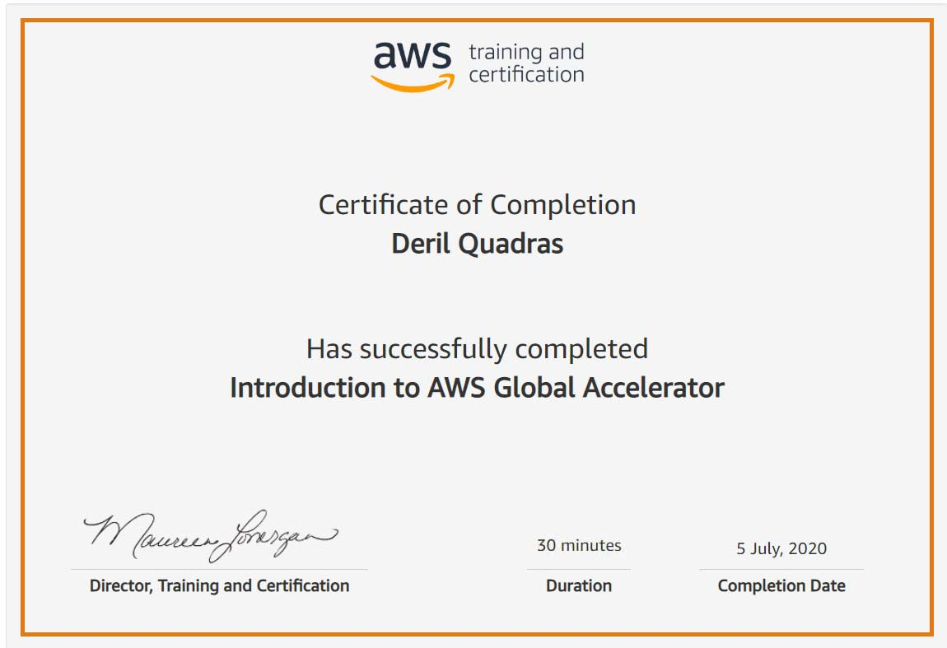

Coding Challenges Details:

**PROGRAM 1 .**

**// Min & Max element in array**

**#include<stdio.h>**

**int main()**

**{**

**int a[50], n, i, big, small;**

**printf("Enter the size of the array: ");**

**scanf("%d", &n);**

**printf("%d\n",n);**

**printf("Enter the %d elements of the array: \n",n);**

**for(i = 0; i < n; i++)**

**{**

**scanf("%d", &a[i]);**

**printf("%d\t",a[i]);**

**}**

**big = a[0];**

**for(i = 1; i < n; i++)**

**{**

**if(big < a[i])**

**{**

**big = a[i];**

**}**

**}**

**printf("\nThe largest element is: %d\n", big);**

**small = a[0];**

**for(i = 1; i < n; i++)**

**{**

**if(small>a[i])**

**{**

**small = a[i];**

**}**

**}**

**printf("The smallest element is: %d\n", small);**

**return 0;**

**}**